**Static-Files**

* Static files are files that don’t change when your application is running.
* Static Files such as Images, CSS, or JS files are often loaded via a different app in production websites to avoid loading multiple stuff from the same server. This article revolves around, how you can set up the static app in Django and server Static Files from the same.

**Step 1:-** Create a folder named with 'static' inside main project folder. It is exactly same as creating 'templates' folder.

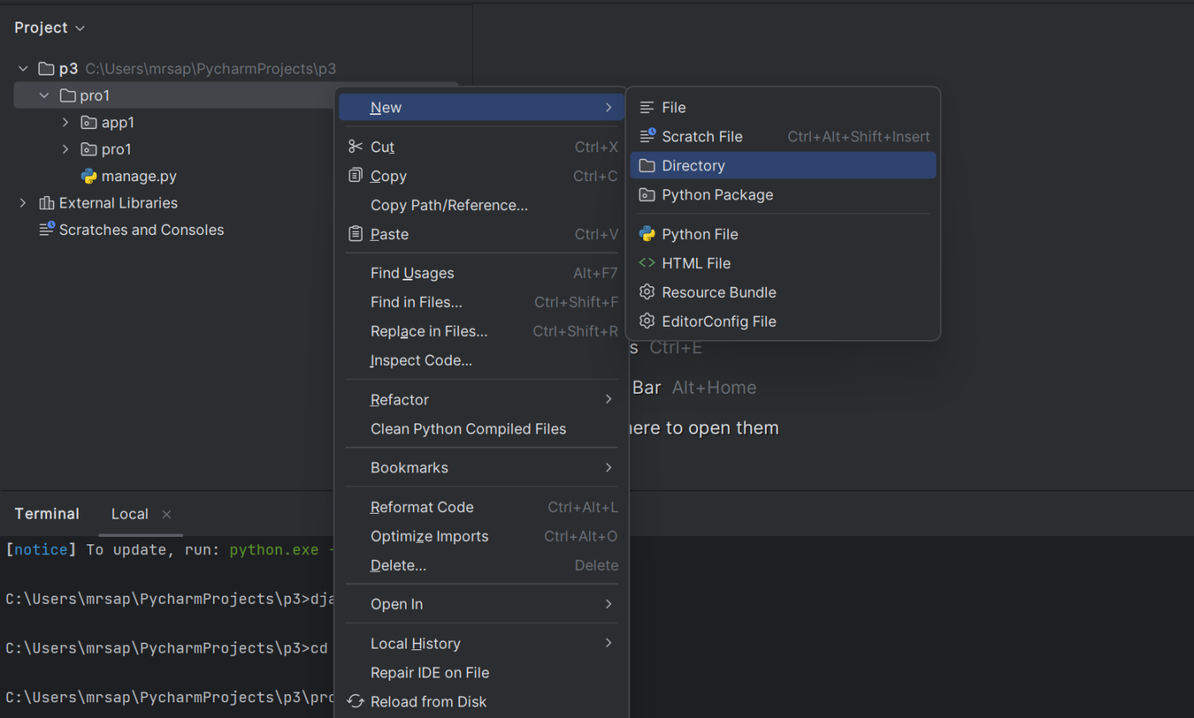

**Step 2:-** In that 'static' folder create 'image', ’CSS’, ’JS ’ folder to place image files,css file,etc.

Right click on “image” folder to open the file in export form and insert img-file in image folder.

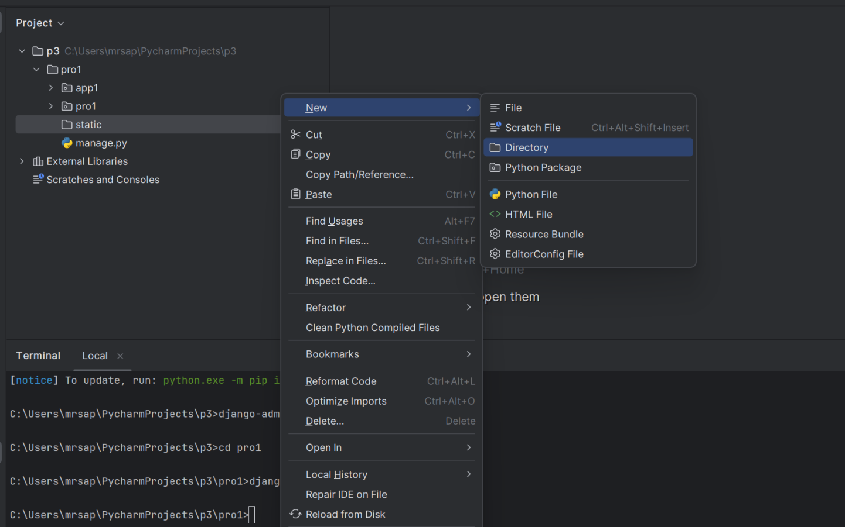

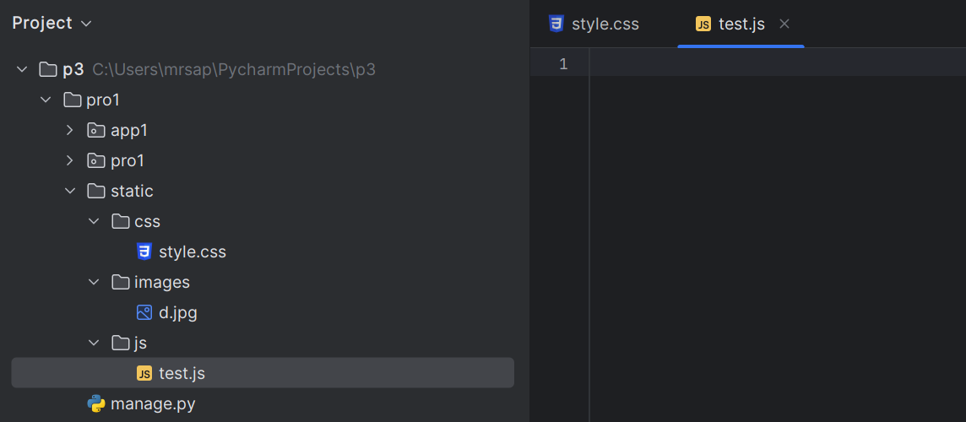

**Step 3:**- Add static directory path to settings.py file, so that Django can aware of our images.

**PROJNAME->PROJNAME->settings.py->STATICFILES_DIRS = ['static']**

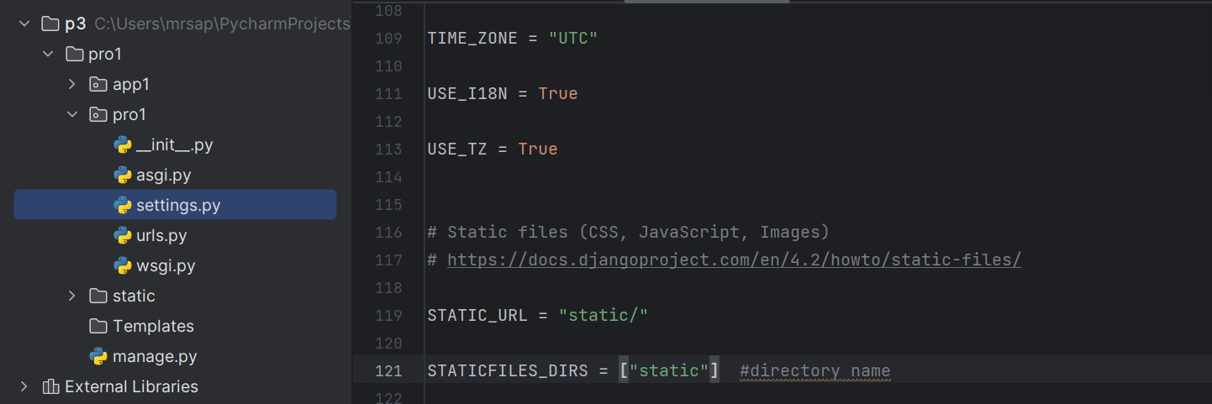

**Step 4:-** Load static files in the templates by using the below expression.

{% load **static** %}

"{% **static** '_____ file path ___________' %}"



